**Universidad Autónoma de Guadalajara**

Ingeniería Electrónica Biomédica

System designing with Microprocessors

*“*Practice 5: LCD Videogame”

Jesús Arnoldo Zerecero Núñez

2885993

Andrea Alejandra Mondragón Olivos

2915351

Practice 5. LCD Videogame

**Introduction**

A Finite State Machine is a way of coding in which the program moves around a series of predefined steps which can be sequential or non-sequential depending on the predefined conditions.

State Machines are used to simplify long, multiple-repeating-step tasks, such as those required to operate a LCD.

In this practice, a simple videogame was created from scratch to be played using a state-machine-controlled-LCD and a pair of buttons. The videogame’s sprites must be totally randomized, and the game must consist of 3 levels and 3 lives before a game over, as well as a score system.

The game created consists of a dog which objective is to catch as many bones as possible while dodging the oncoming snakes. The dog moves up or down while the sprites move towards it at increasing speeds (controlled by the KL25z’s PIT module). Each bone adds a point to the score, and each five points the next level is reached. Touching a snake subtracts one life and losing 3 ends the game. One button makes the dog move while the other pauses or resumes the game.

The dog, bone, snake and lives sprites were generated and saved in the LCD’s RAM blocks.

**Development.**

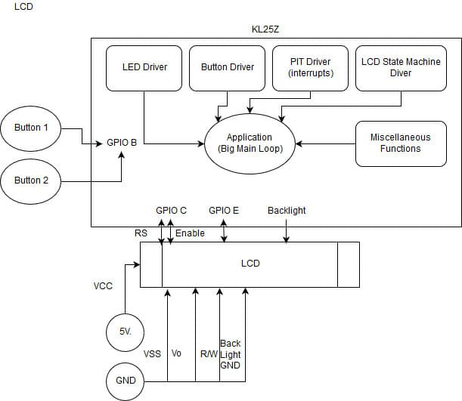**Block diagram/modules implemented:**

**Conclusion:**

LCDs are slow devices because communicating with them requires leaving delays between the data sent and received. To compensate this, the delays are made non-blocking, using the code’s other functions as a delay. Instead of waiting for the delay to finish and putting the code on pause, the code may go ahead and execute other tasks in the meanwhile, therefore being more efficient.

Multiple state machines may be executed at once, each with their own conditions and steps. This state machines may or may not be dependent from one another, perhaps one of them is inside the other to accomplish a mini task. A pivot state is non-sequential step which can be accessed from any other state in the machine as a reference, starting or reset point.

**Link to video demonstration:** [**https://photos.app.goo.gl/Jg1hbGo2Ihwpz46j2**](https://photos.app.goo.gl/Jg1hbGo2Ihwpz46j2)